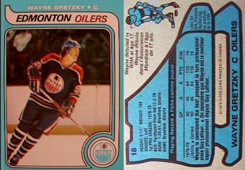
Elements ‘Hockey Card’
You will be working in groups of 2.
- Each group will be assigned ONE of the ‘common elements’ so that each of them will be covered. The common elements are: Hydrogen, Iron, Oxygen, Sodium, Chlorine, Mercury, Silver, Carbon, Nitrogen and Silicon. In addition, you will look at ONE other element of your choice.

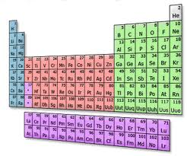
- Your group needs to gather the information for each element listed in the tables provided. There are plenty of resources available. You will create a ‘hockey card’ to display your information. The hockey card must be ¼ of a regular piece of paper, or 10cm x 14 cm. The information that should be displayed on your card is listed in the information tables below. Your cards can be hand-drawn or done on the computer (they must be printed off and be double sided).

- The general layout of the card will include the following information
Front of card:the front of the card has the general information.  Name – what is the name of the element (can include a nickname as well)  Symbol – the element’s symbol  Jersey Number – this should be the element’s atomic number.  Picture - this can either be the element by itself (such as a bar of gold) or the element within another substance (potassium within a banana)  Team – Is it a metal or a non-metal. If the element belongs to a particular family you can include that as well. | Back of card:the back of the card has the statistics and other information for the element.  What year was the element discovered?  Who discovered the element?  What is the atomic mass of the element?  What common items contain this element?  At least one interesting fact.
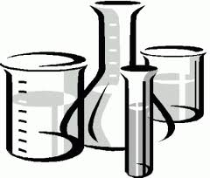
Names:_______________________
____________________________
Block: ____ Date: __________Common’
Common Element Name:  Element Symbol:  What is the atomic number? (# of protons) :  What is the atomic mass Metal or Non-metal?:  Does the element belong in a certain family (ex. Halogens? Noble Gases?) :  What common items contain this element? (name at least 2)  If none, where might you find this element?  What year was the element discovered and by who?  Any other interesting facts (at least one). | Chosen Element Name:  Element Symbol:  What is the atomic number? (# of protons) :  What is the atomic mass Metal or Non-metal?:  Does the element belong in a certain family (ex. Halogens? Noble Gases?) :  What common items contain this element? (name at least 2)  If none, where might you find this element?  What year was the element discovered and by who?  Any other interesting facts (at least one).
Handing in your hockey card physically:
- After you complete creating a virtual hockey card (see instructions below) you must still hand in the completed hockey card.
Handing in your hockey card virtually:
- Take high-quality photos of both sides of your hockey card.
- Open up a Google Document and paste your photos of your hockey card Element #1 in the document side by side. Then, underneath the hockey card, please write your names.
It should look like this:
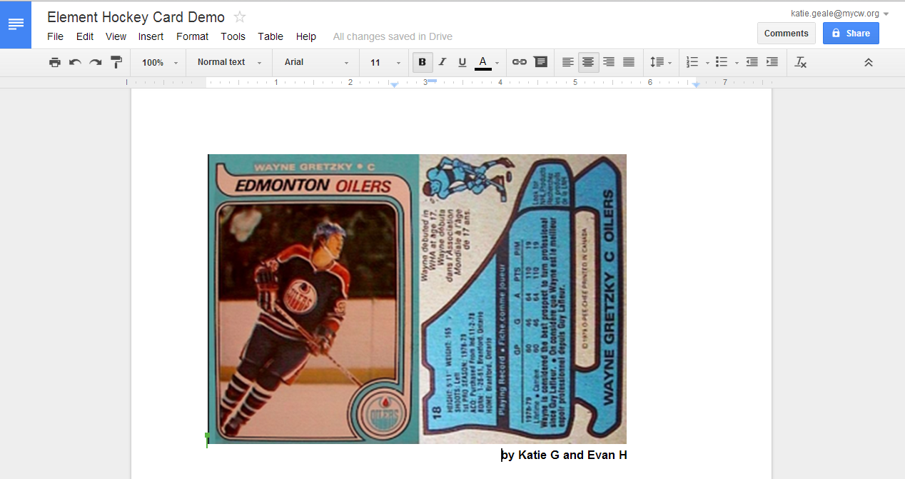

- Once your google doc is complete, please click on “File” then “Publish to the Web”

- Do NOT click “Require viewers to sign in…” but make sure that “Automatically republish when changes are made is checked
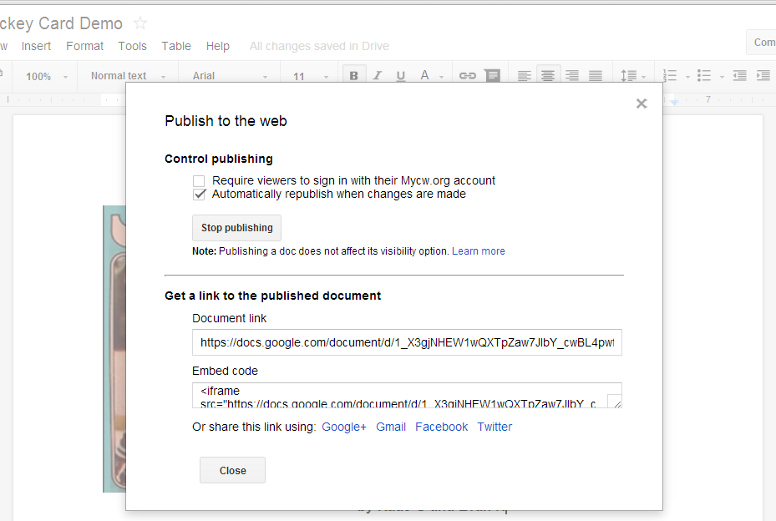

- Get a link to the published document. Under the title “Get a link to the published document, there is a “Document Link”. Copy that whole link to a word document and label it Element #1.
- Repeat Steps #1-5 with your Element #2 hockey card.
- Copy that whole link. Copy that whole link and label it Element #2.
- Submit both links using these google forms below (be sure to choose the correct class!)
Science 9 A Block (Hall): http://goo.gl/Fd2U6t

Science 9 E Block (Hall): http://goo.gl/C3CjqP

Names:
Use of class time/Link sent | Student not using class time productively. (1-2) | Student is on task most of the time. (3-4) | Student in always on task. (4) A link to the hockey card document is provided (1) | 5
Information | Most of the information provided is inaccurate or missing. (1-3) | Most of the information is included and accurate. There are at least two ‘common items’ listed for both elements. (4-7) | All of the information selected is included and accurate. There are at least two ‘common items’ listed for both elements(8-10) | 10
Interesting Facts | None provided or else fact is irrelevant or already listed. (1) | One fact provided that is interesting and relevant. Description of fact may not be detailed. (1-4) | More than one fact provided that is interesting and relevant. Description of this fact is detailed. (5) | 5
Hockey Card Layout and Creativity | Hockey was incomplete or shows minimal information. No picture is included and card lacks creativity (1-4) | Hockey card descriptive, including picture(s) of elements, Card is generally creative (5-7) | Hockey Card is visually attractive, informative and includes picture(s) of the elements. Lots of creativity is shown. (8-10 | 10
 |  |  |  | 30
Elements Hockey Card Rubric: STUDENTS NEED TO FILL THIS OUT (in pencil)

